**Video Game Design Document**

**Game Overview**

**Synopsis:** Players control the Whiskered Wardens, defending the Holy Cheese from waves of Pinktail Posse attackers.

**Game Vision:** Charming yet intense battles, strategic defense, whimsical world-building.

**Unique Selling Points:** Unique cheese-based magic, evolving enemy threats, feline warriors.

**Platform(s):** *PC (Steam), mobile*

**Target Audience:** *Strategy lovers, fantasy enthusiasts*

**Game Title:** *Holy Cheese!*

**Genre:** *Tower Defense / Adventure*

**Story & Narrative**

**Setting:** Swiss Summit Farms - *A mystical land of dairy riches, where feline guardians defend the Holy Cheese from the gnawing forces of the Pinktail Posse.*

**Themes:** *Loyalty, guardianship, the price of power.*

**Main Characters:**

**Protagonists:**

1. **General Clawdius Maximus** – *The Iron Paw*

* Battle-hardened warrior with increased durability and resilience.
* Special Ability: **Guardian's Roar** – Grants temporary invincibility to surrounding feline towers.
* **Ironpaw Bastion -** A sturdy **fortified tower**, built to withstand heavy rat assaults while boosting surrounding defenses.

1. **Sir Pounce-a-Lot** – *Swiftblade Sentinel*

* Dual-wielding claws deliver rapid strikes, cutting down enemies quickly.
* Special Ability: **Royal Pounce** – Leaps across the battlefield, dealing bonus damage.
* **Pounce Tower -** A rapid-strike tower where Sir Pounce-a-Lot leaps between platforms, attacking multiple rats in succession.

1. **Meowdusa** – *Serpent-Eyed Defender*

* Mesmerizing gaze stuns enemies, freezing them in place momentarily.
* Special Ability: **Stoneglare Curse** – AOE petrification effect that slows or immobilizes nearby rats.
* **Stonegaze Tower -** A mystical defense that **paralyzes enemies**, turning them into immobile stone for a brief period.

1. **Purrlin the Mage** – *Arcane Cheese Weaver*

* Harnesses the mystical energy of the **Holy Cheese** to enhance towers.
* Special Ability: **Cheese Enchantment** – Temporarily buffs nearby towers with magic-infused strikes.
* **Arcane Cheese Tower -** Channels enchanted **cheese magic**, periodically empowering nearby towers with extra attack power.

**Antagonists:**

1. **Graybeard the Gnawer** – *The Veteran Tactician*

* An ancient rat leader with unparalleled battlefield knowledge.
* Boss Ability: **Rally the Horde** – Temporarily increases the speed and aggression of all surrounding minions.

1. **Fleablight** – *The Plague King (Fleabomb)*

* A bloated rat carrying **swarms of parasitic fleas**, spreading them across towers.
* Boss Ability: **Infestation Burst** – Covers an area in fleas, temporarily weakening defenses.

1. **Stormtail** – *The Thundering Menace (Voltfang)*

* An electrified rat infused with **unstable bioelectric energy**, sending shockwaves through the battlefield.
* Boss Ability: **Overload Surge** – Releases a massive energy burst, **stunning** towers and wardens in its path.

1. **Chitterjaw** – *The Maw That Never Closes (Bonecruncher)*

* A grotesque rat with oversized jaws that **never stop gnawing**, chewing through even the toughest barriers.
* Boss Ability: **Gnawing Frenzy** – Locks onto a single tower and **destroys it completely** if left unchecked.

1. **Rat** **King** – *The Ultimate Mutation*
   * A terrifying fusion of all **mutated rats**, wielding **multiple abilities at once**.
   * Boss Ability: **Chaotic Evolution** – **Randomly changes form mid-battle**, cycling through different rat mutations.

**Opening Scene**

**Location:** *Swiss Summit Farms – Chamber of the Holy Cheese (storeroom)*  
**Time:** Midnight – under a glowing milky moon  
**Description:** A room with rows of shelves made entirely of wood, lined with towering Swiss cheese wheels. The air is thick with the scent of dairy magic.

**[CUTSCENE] – Comic book style with voiceover.**

* The **Holy Cheese** sits atop a golden pedestal, pulsing faintly with mystical energy.
* **The Whiskered Wardens**, led by **General Clawdius Maximus**, stand in formation, tails flicking in readiness.
* A low rumbling echoes as the **Pinktail Posse** approaches—shadowy figures dart through the moonlight.

**Dialogue:**  
**(Clawdius Maximus)**: "The cheese must be protected at all costs! The magic within it must never fall into gnawing paws!"  
**(PINKTAIL Captain Graybeard)**: "Eight lifetimes you’ve held the cheese. Tonight, that changes."

**Key Story Events**

* **Battle Begins:** First wave of normal **PINKTAIL POSSE** rats breach the Chamber of the Holy Cheese, storeroom.
* **End of First Battle Twist:** Pinktail special forces, **THE RODENT REAPERS**, breach the Holy Cheese perimeter stealing chunks.
* **Second Level Battle:** The first mutated rat joins the attack.
* **First Loss:** The loss of towers due to rat attacks. Removes that tower type from play until next level.
* **Transformation:** Rats transform with each level. Cutscene between levels reveal what and how the transformation happens.

**Ending Scene**

**Final Conflict:** The Pinktail Posse leader, the final mutant who is a chimera of all other mutant rats, stands before Clawdius Maximus. One last stand remains.  
**Resolution:** Victory the rats are defeated, or defeat turns the farm into a gnawed wasteland.  
**Possible Endings:** The Holy Cheese remains, or the rodents reign supreme.

**Gameplay Section**

**Objective:** Defend the Holy Cheese from 5 waves of invading Pinktail rats!  
**Player Actions:** Deploy feline warrior towers and traps in strategic locations along the route to stop the rats.

**Player Strategy:**

* Holy Cheese gets eaten down as more rats get through, game ends when all cheese is gone
* Towers can be upgraded as the game goes on

**Quality of Life:**

* If game turns off midlevel, auto save returns them to the start of the wave.
* Game can be saved midlevel with return to beginning of wave.

**Enemies/Challenges:**

1. **Basic Squeakers**

* Small normal gray rats.

1. **Flashpaws**

* Lightning-fast rodents that dodge strikes and bypass barriers with unpredictable movement.
* Their extreme agility comes at the cost of endurance, making them tire quickly in prolonged battles.
* White rat with elongated legs and feet
* 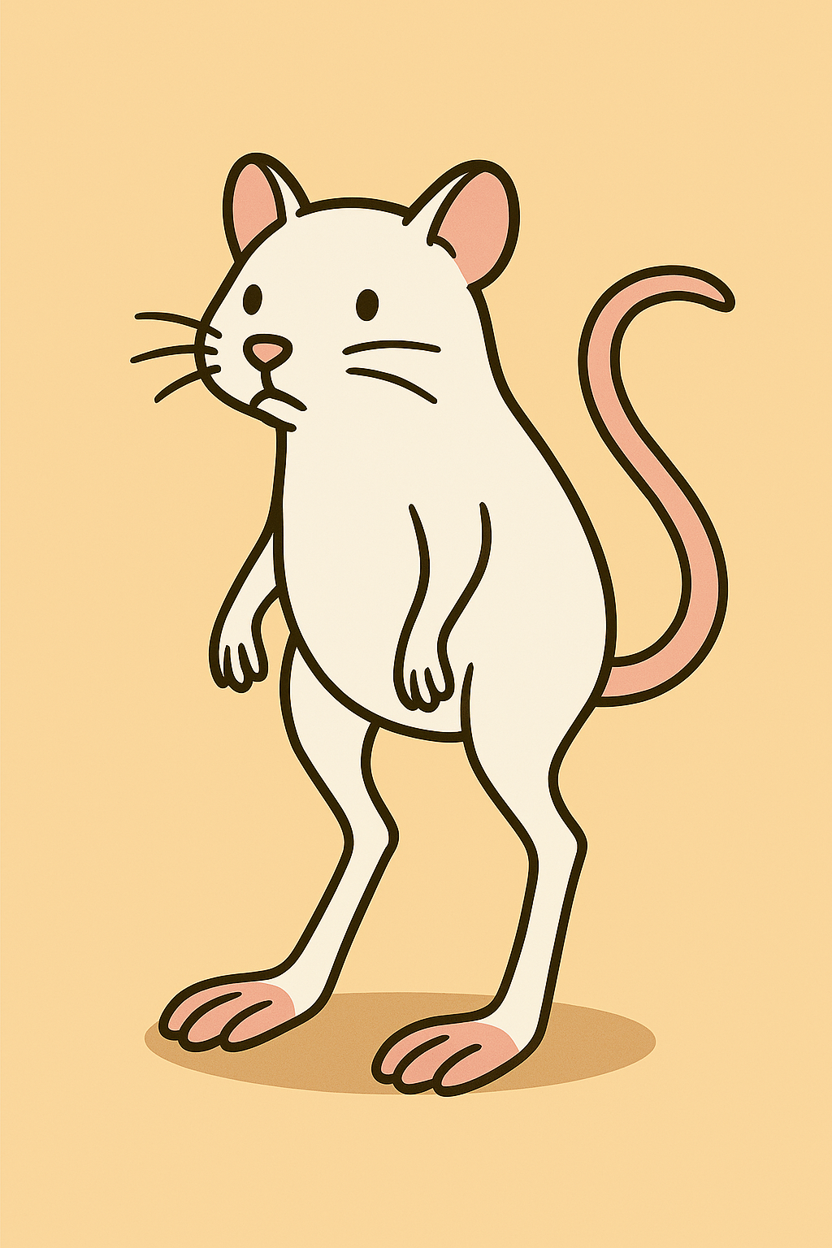

.

1. **Mindwhiskers**

* Hyperintelligent rats that analyze defenses and reroute attacks to avoid traps.
* Their advanced intelligence makes them hesitant—overanalyzing decisions causes delays in their attacks.
* Pink rats with a large cranium.
* 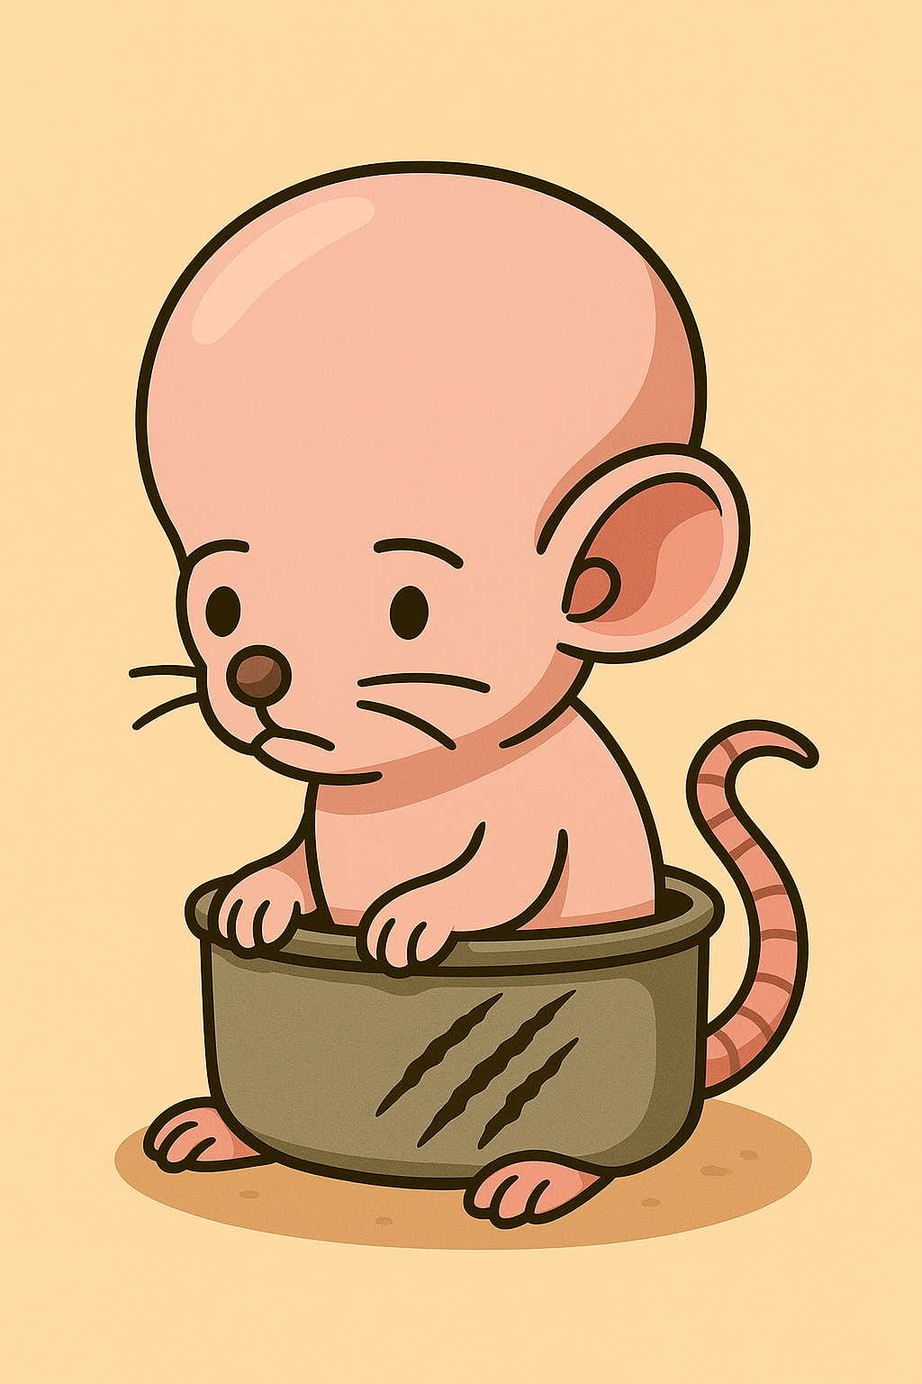

1. **Titantails**

* Massive, muscular rats that smash through obstacles and resist damage.
* Their massive size slows them down, making them vulnerable to ranged attacks and strategic traps.
* A large dark gray muscular rat.
* 

1. **Voltfangs**

* Electrified creatures that stun enemies with bioelectric shocks and disrupt formations.
* Their bioelectric charge requires time to recharge, leaving them temporarily exposed after shocking an enemy.
* White rats the glow and have lightening between whiskers.
* 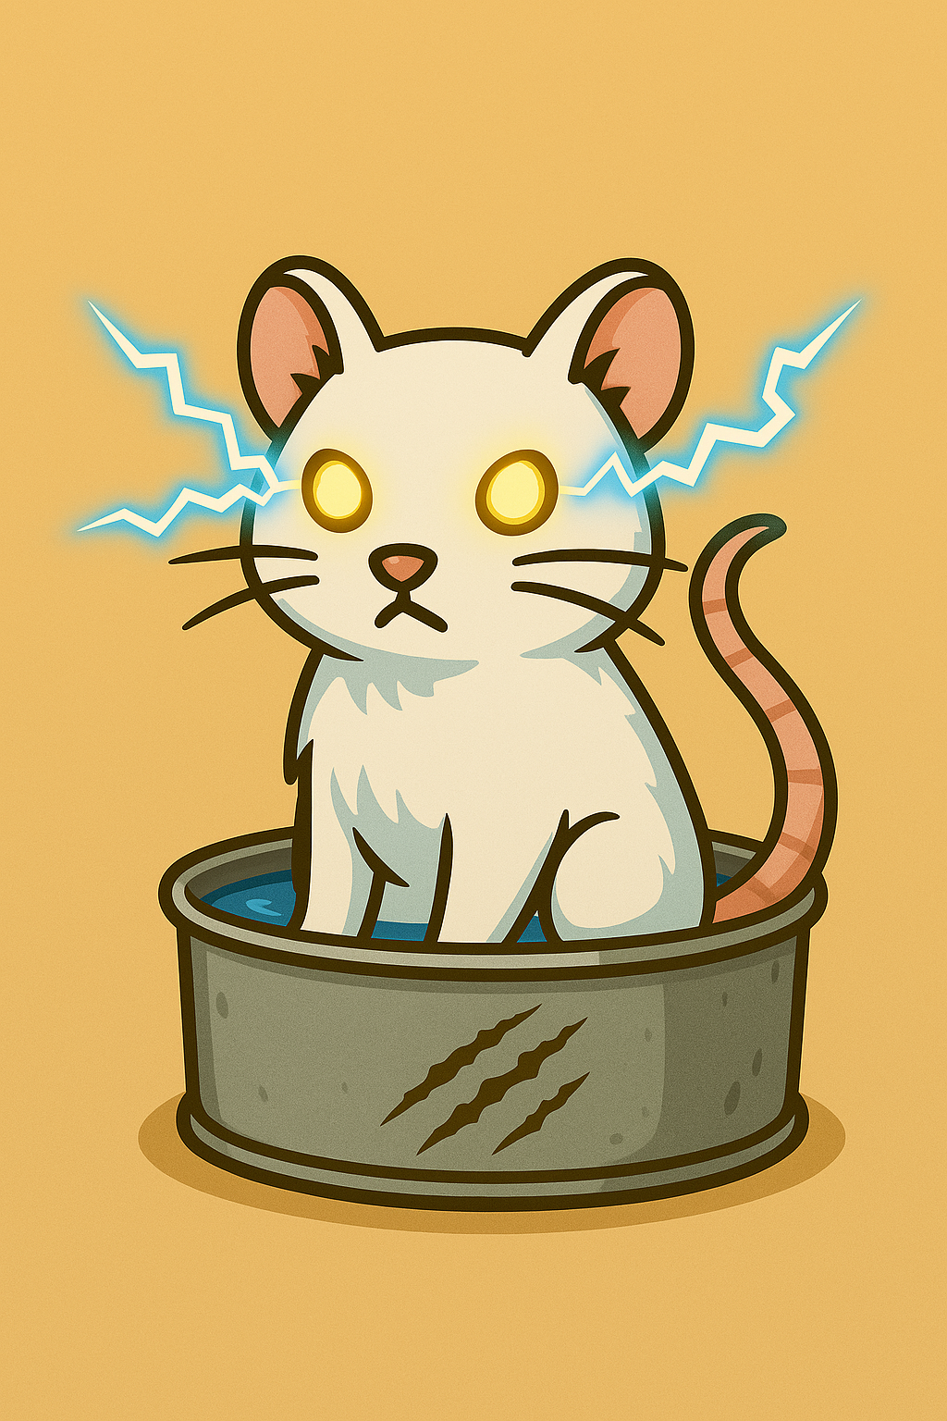

1. **Shadowsnouts**

* Stealth rats that turn invisible until they strike.
* Bright light reveals their position, making them easy targets.
* Black rats that get smokey
* 

1. **Gutrotters**

* Toxic rats that exude fumes to weaken enemies and corrode structures.
* Their own toxicity gradually drains their health.
* Green rats with toxic gas around them
* 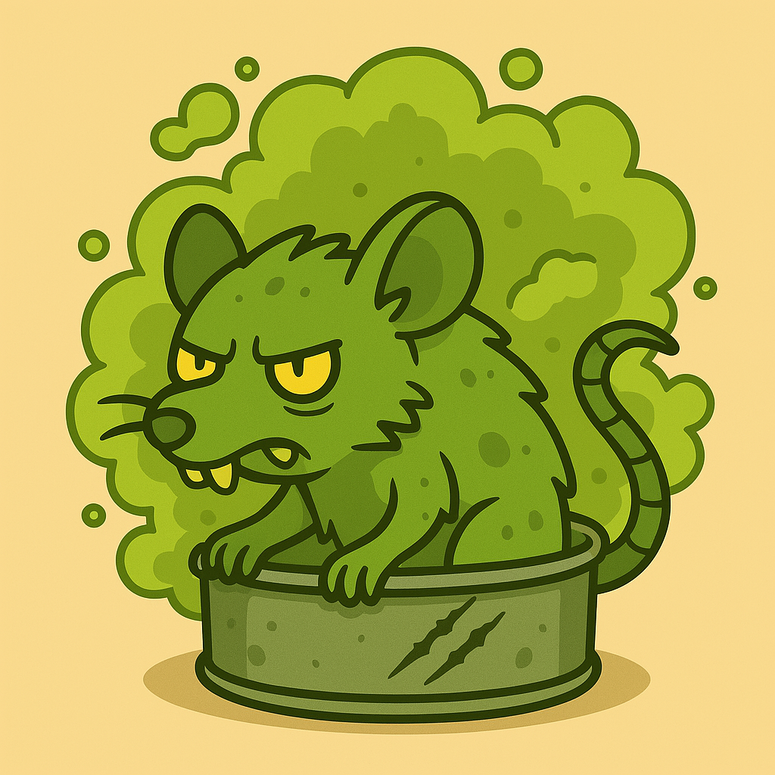

1. **Bonecrunchers**

* Razor-toothed rats that chew through even the toughest defenses.
* Their jaws require time to regenerate after heavy use, leaving them defenseless.
* Brown rats with large teeth.
* 

1. **Shriekmaw**

* Sonic attackers that emit piercing screeches to stun opponents.
* Their sonic attacks don’t work in enclosed spaces where sound is dampened.
* Gray rats with big mouths.
* 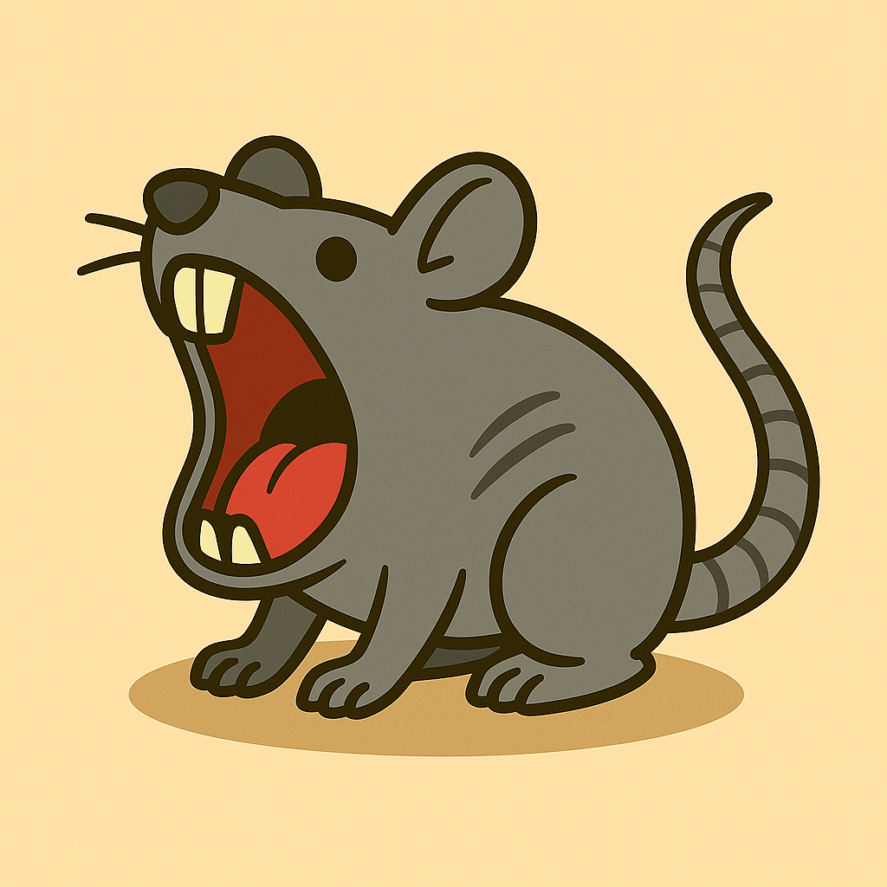

1. **Cinderfur**

* These rats can ignite small flames with their breath or body friction.
* Their bodies are highly volatile—uncontrolled fires can damage their own forces.
* Red rats with fire coming off them
* 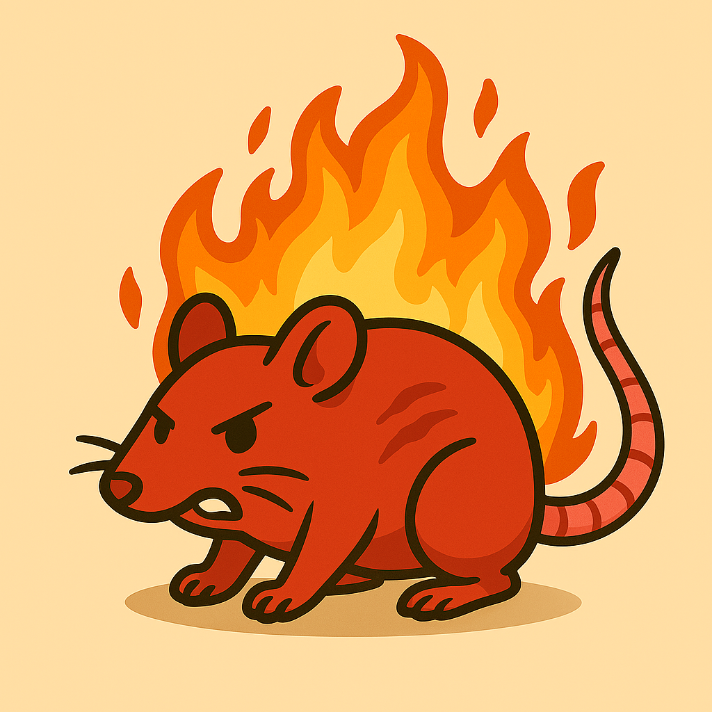

1. **Frostfeet**

* These rats emanate freezing temperatures, slowing enemy movements and encasing objects in ice.
* Cold weakens their agility, making them sluggish in warmer environments.
* Blue rats with little icicles.
* 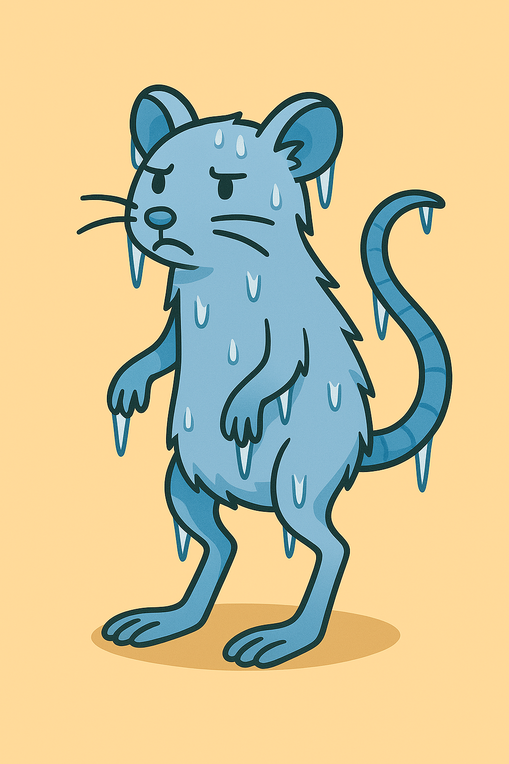

1. **Fleabombs**

* These rats carry swarms of parasitic fleas, launching them at towers to weaken defenses.
* Fleas slow attack speed and cause temporary debuffs to feline warriors.
* Fleabombs are highly susceptible to fire-based towers, as heat eradicates their parasites instantly.
* Mangy gray rats with little black specks.
* 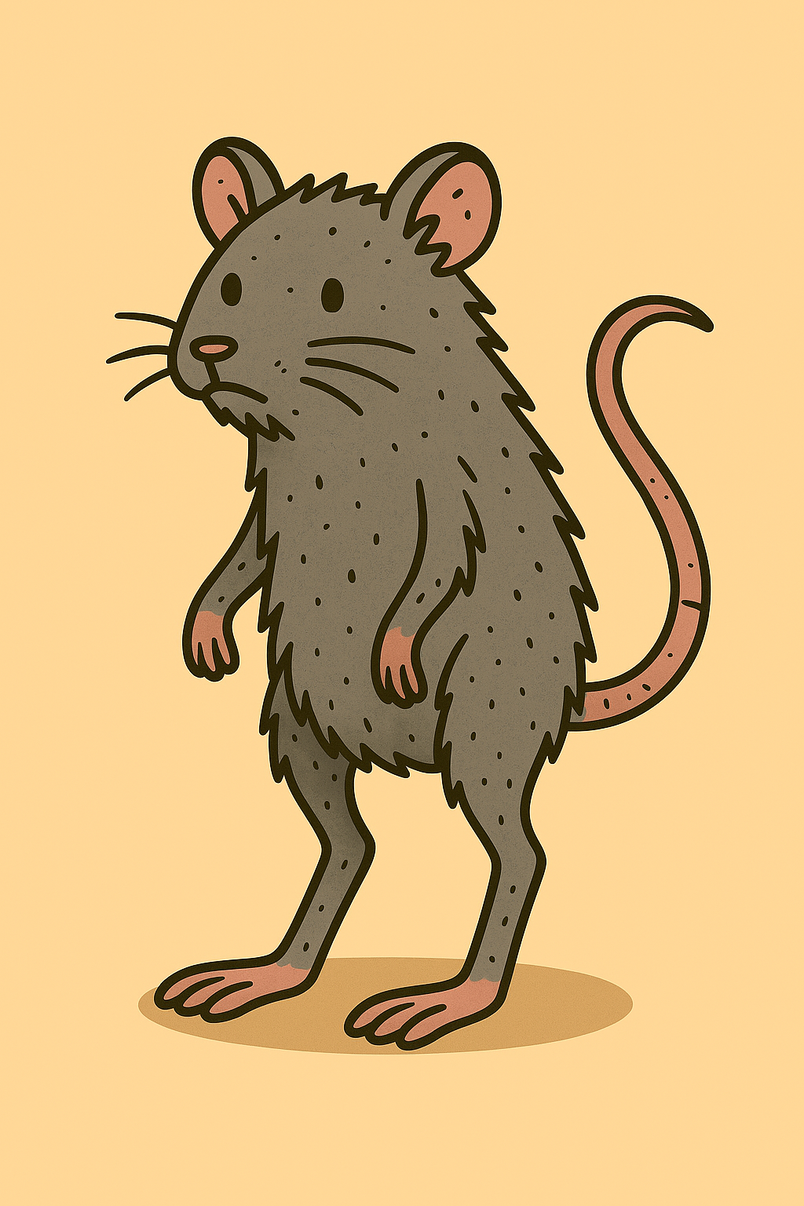

1. **Chewtank**

* A rat operated vehicle made of moldy cheese that when destroyed releases an army of baby basic squeakers.
* High-impact explosives or continuous damage towers to break it down before it reaches key defenses.
* A tank made of moldy cheese with a little rat driving it.
* 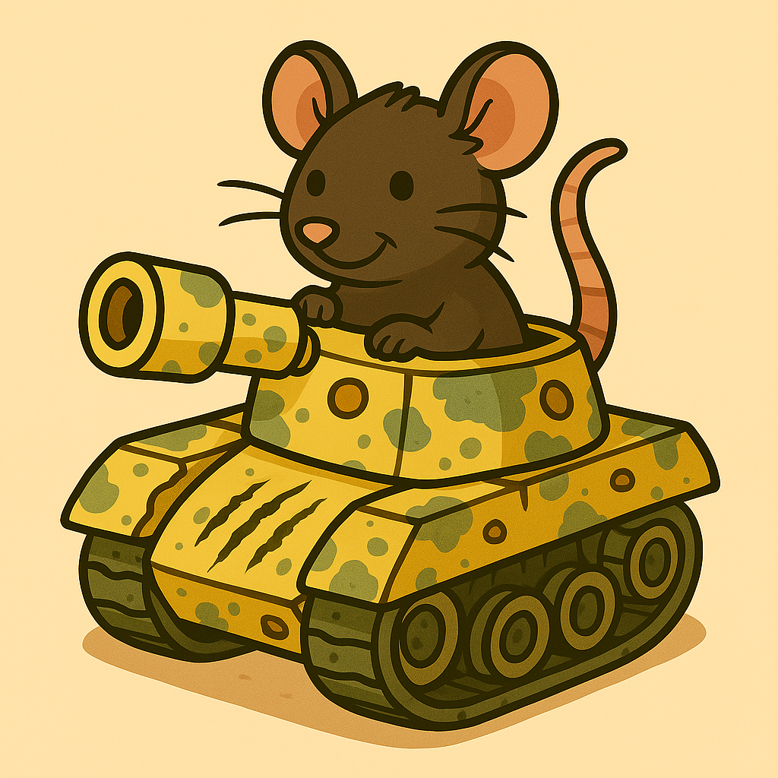

**Feline Defense Towers:**

1. **Basic Claw Tower – Swift Strikes & General Defense**

* A standard defensive unit with razor-sharp claws that swipe at passing rats.
* High attack speed but moderate damage.
* Ideal for thinning out waves before stronger towers finish them off.
* A cat in a box with scratch marks on it.
* 

1. **Sticky Paws Tower – Slowdown Mechanic**

* Cats pounce onto rats with sticky paws.
* Rats move at half-speed for a short duration, making them easy targets.
* Works best when combined with high-damage towers.
* A cat in a peanut butter jar with peanut buttery paws.
* 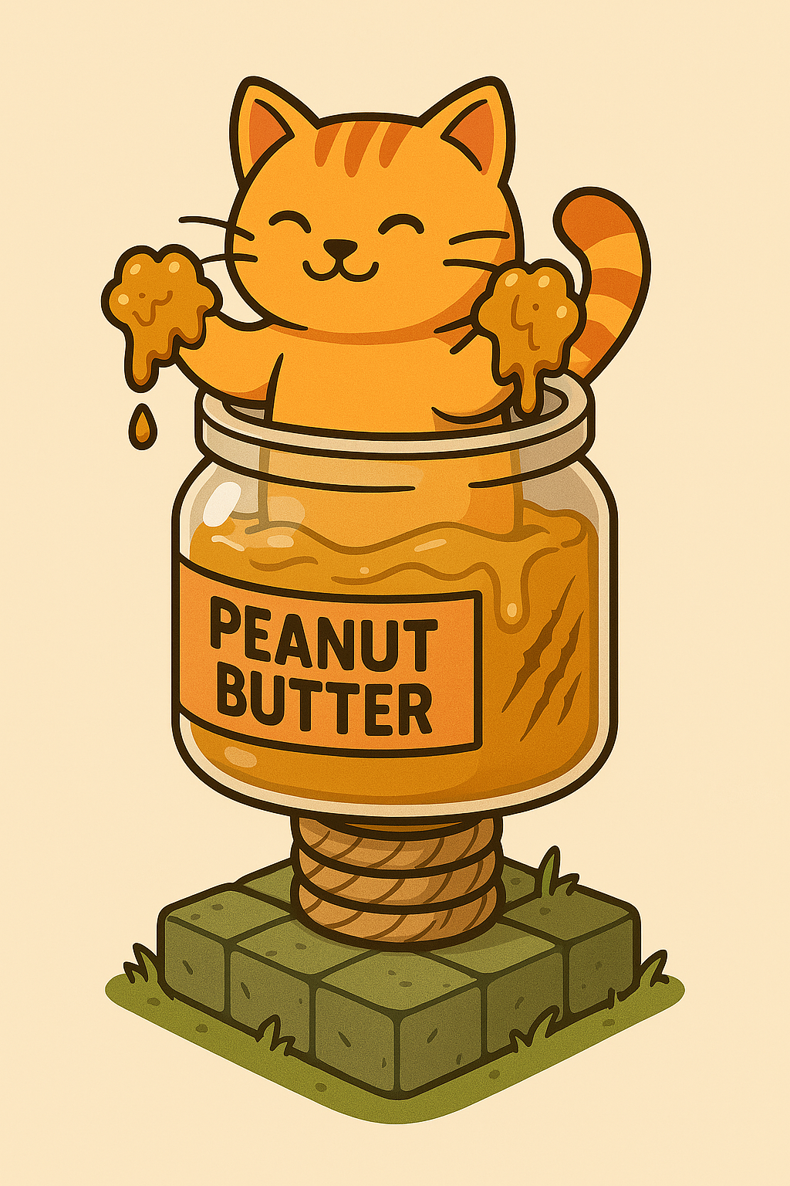

1. **Cat Nap Tower – Confusion & Temporary Halt**

* Emits a calming aura, tricking rats into thinking it's a safe resting spot.
* Causes them to stop and daze briefly before resuming their path.
* Works well near high-damage areas where stalled enemies can be eliminated efficiently.
* A cat asleep on the top of a small cat tree.
* 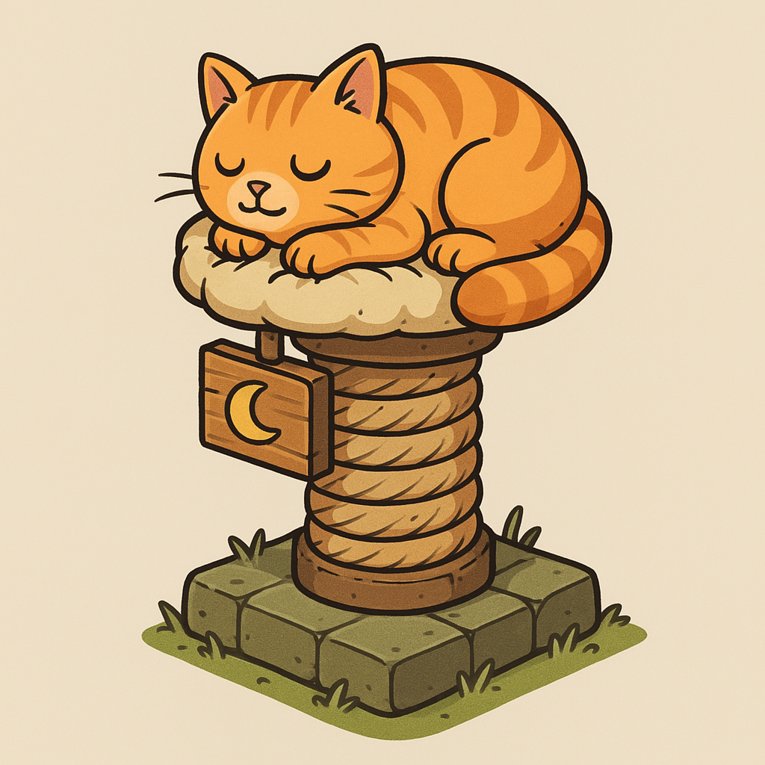

1. **Pied Piper Tower – Rhythmic Distraction**

* Produces hypnotic melodies that force rats to follow an alternate longer path.
* Dazed rats are unable to attack for a brief period.
* Strong against large clusters, giving other towers time to strike.
* A cat playing a flute in a basket.
* 

1. **Yarn Ball Tower – Rolling AOE Damage**

* Cats slap giant yarn balls down the path, crushing rats in an area of effect.
* Yarn slows slightly as it rolls, giving prolonged damage to enemies in its wake.
* Effective against large enemy waves but requires cooldown between hits.
* A cat in a pile of yarn.
* 

1. **Hero Towers – Elite Customizable Units**

* Legendary cats with unique abilities that can be leveled up and customized.
* Examples: *Sir Pounce-a-Lot* (high single-target damage) or *Purrlin Mage* (casts cheese magic to weaken enemies).
* Can be upgraded with special traits based on player strategy.

1. **Mouse Trap Tower – Deployable Instant Damage**

* Launches mechanical traps onto the path that snap shut when rats step on them.
* Instant-kill weaker enemies and deal heavy damage to tougher ones.
* Requires strategic placement for maximum effect.
* A cat inside a box of mouse traps.
* 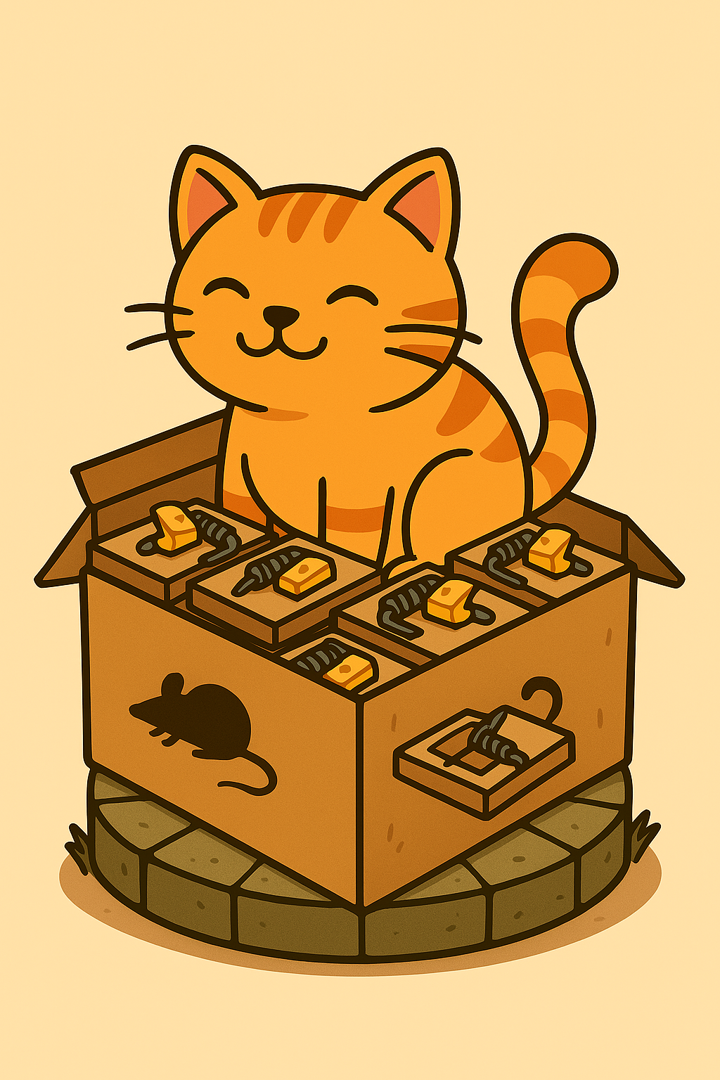

1. **Sticky Trap Tower – Wide-area Slow Effect**

* Throws glue-covered traps onto the battlefield, forcing rats to slow down significantly.
* Works exceptionally well when placed before powerful attack towers.
* The glue eventually wears off, making timing crucial.
* A cat stuck on a sticky mouse trap.
* 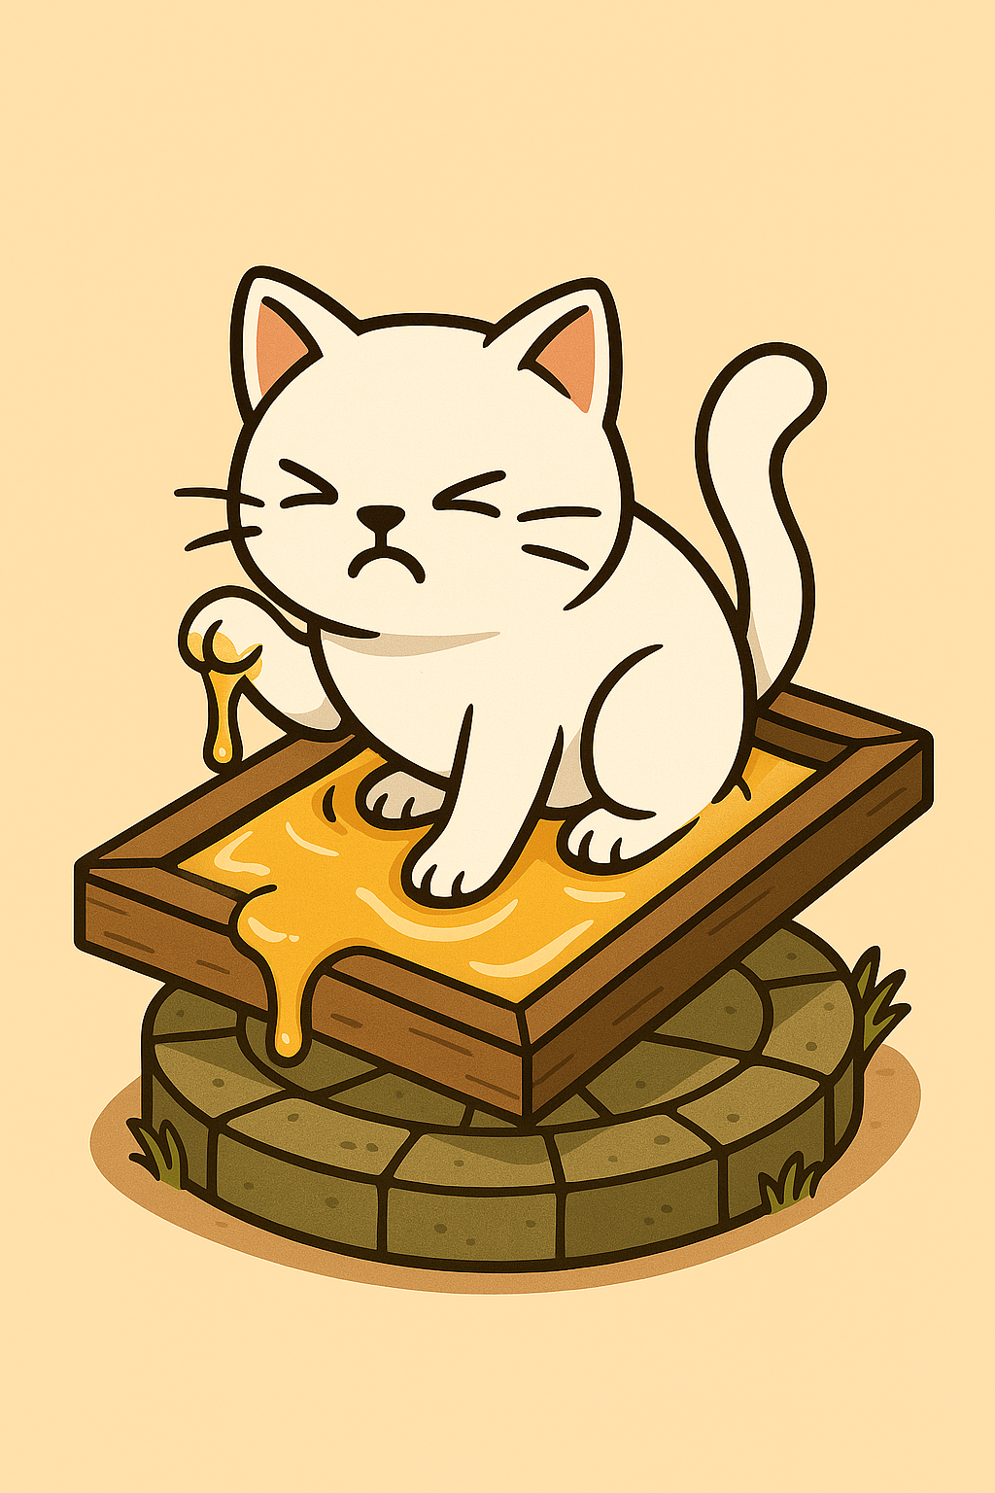

1. **Fish Bone Tower – Piercing Single-Target Damage**
   * Cats fling sharpened fish bones at oncoming rodents.
   * Hits only one target at a time but has high precision and damage.
   * Best used against high-health enemies to chip away at their defenses.
   * A cat inside a pail of fishbones.
   * 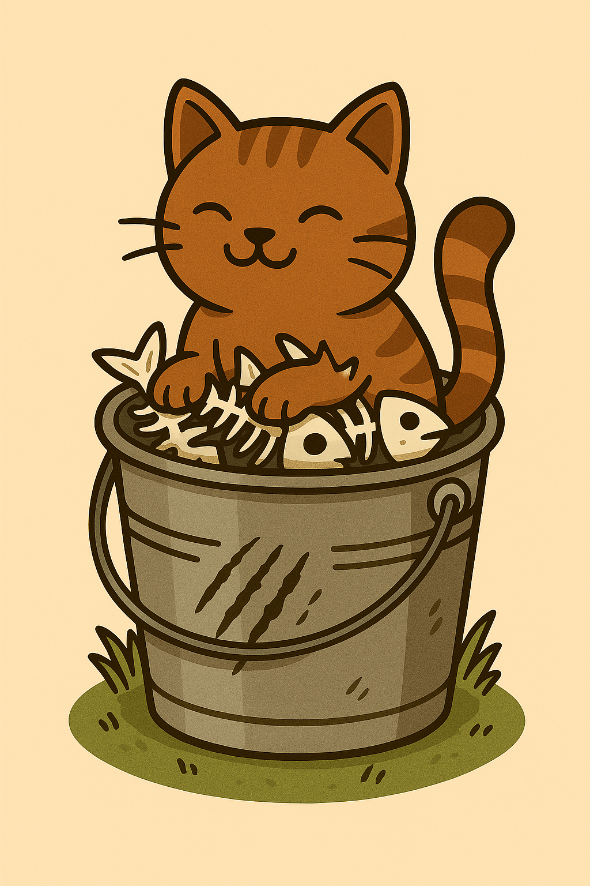
2. **Tuna Storm Tower** – **High-Speed Projectile Barrage**

* Rapid-firing cans of tuna that explode on impact, scattering fishy shrapnel over a wide radius.
* Great for clearing waves of smaller rats but has a cooldown between volleys.
* A cat sitting inside an empty tuna can.
* 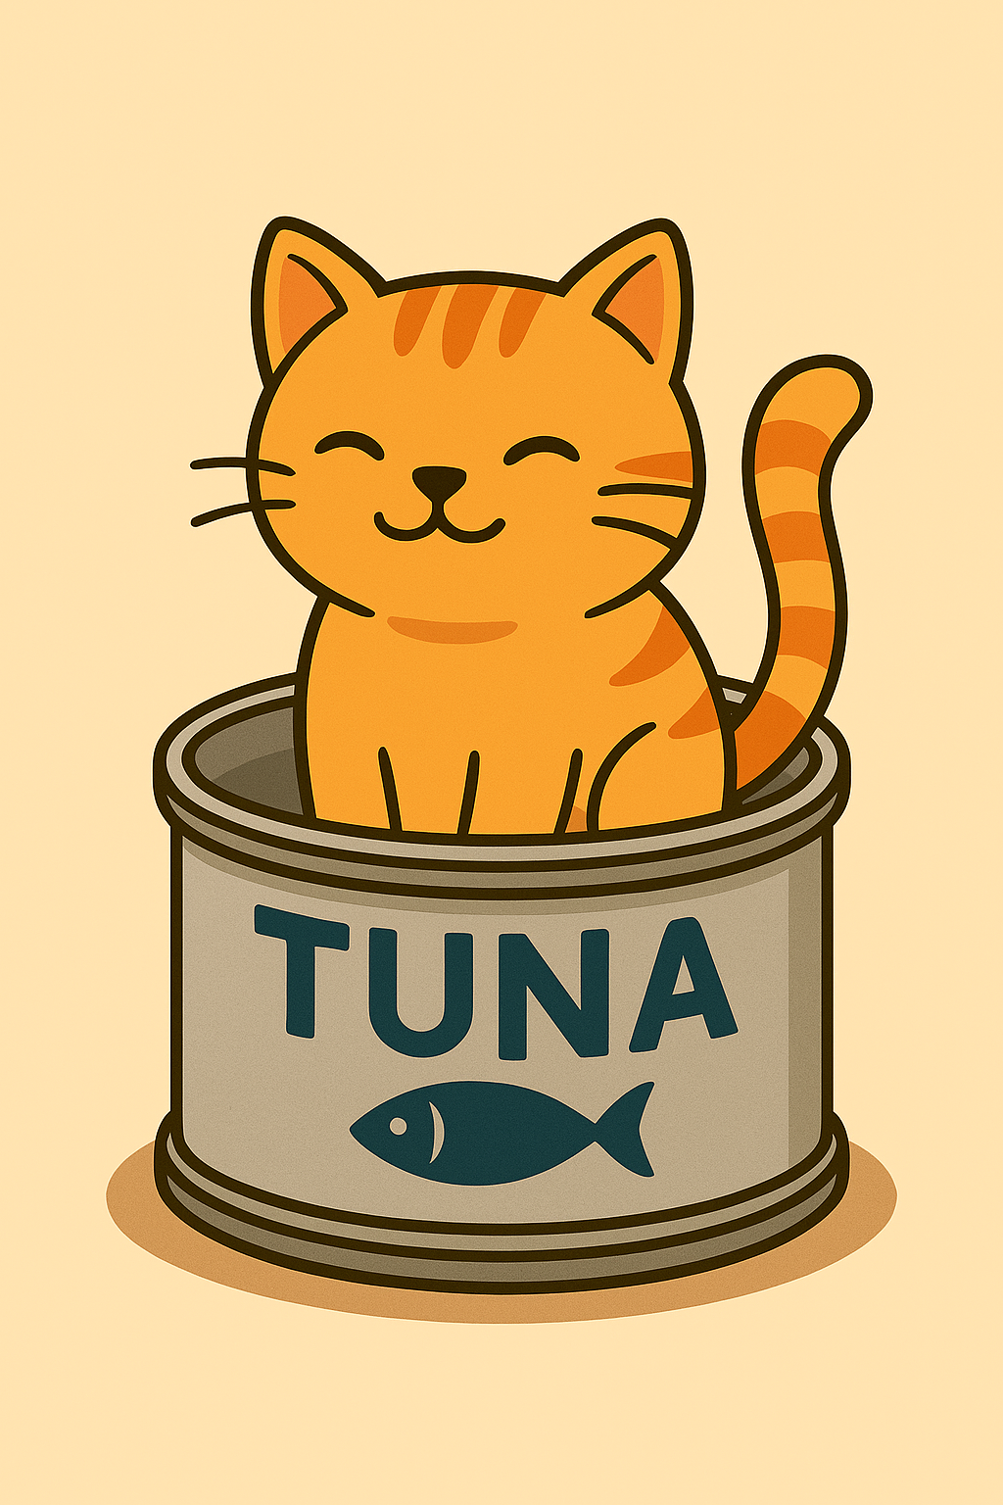

1. **Drenched Paw Tower** – **Water-Based Suppression**

* Fires high-pressure water jets, dousing flames and slowing enemies in its path.
* Strong against Cinderfur, Shriekmaw, and Voltfangs, as water disrupts sound waves and shorts out bioelectric charges.
* An unhappy looking cat sitting in a bucket of water.
* 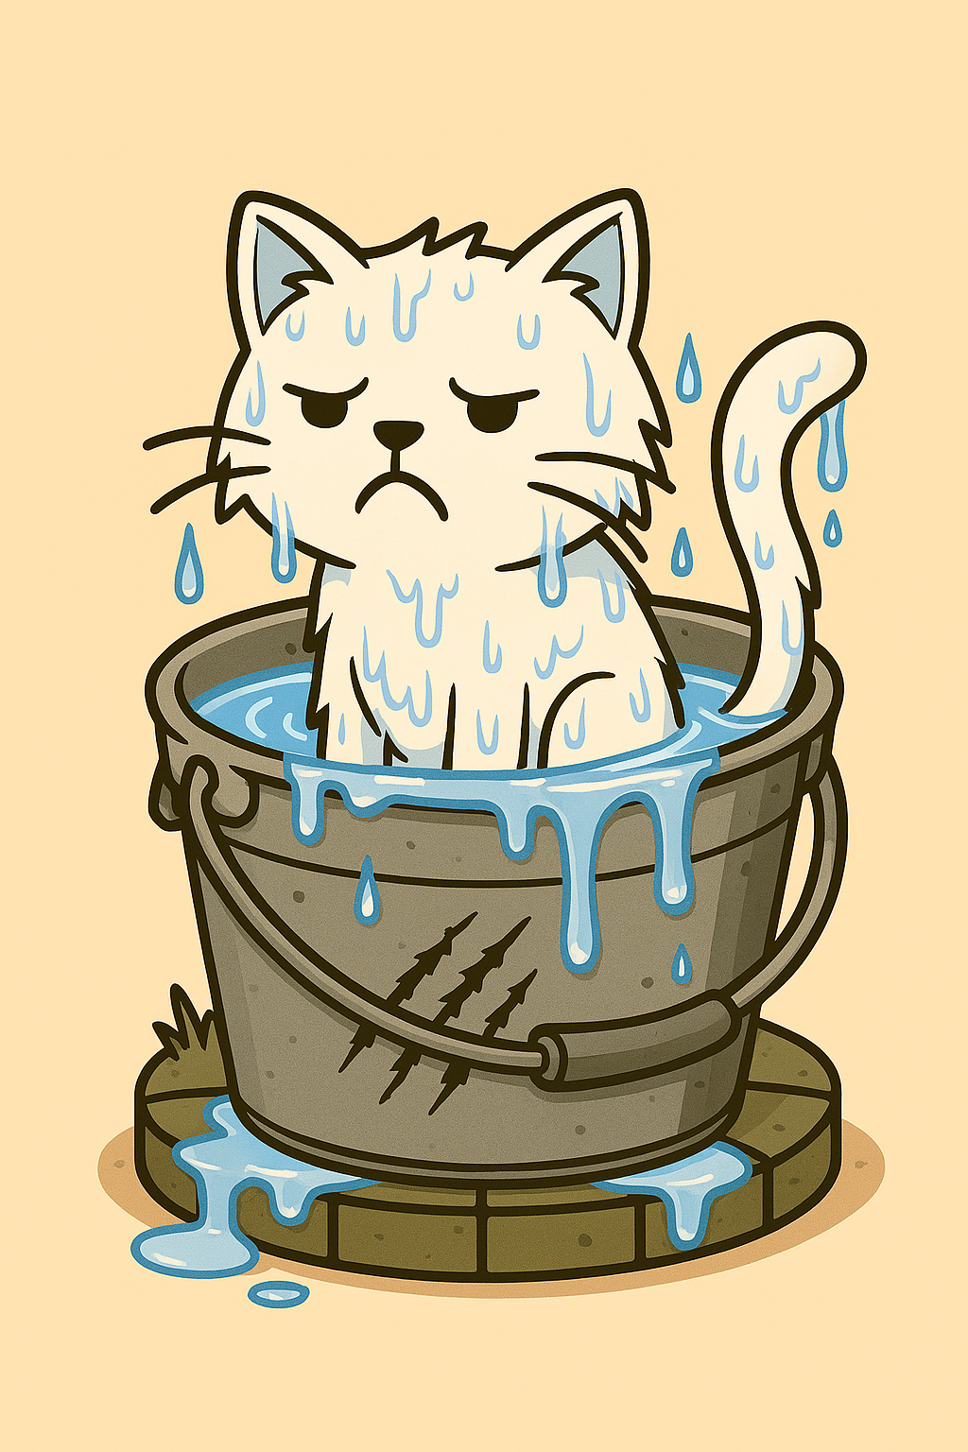

1. **Blazing Whisker Tower – Fire-Based AOE Damage**

* Cats unleash scorching firebursts that ignite enemies, dealing damage over time.
* Strong against Fleabombs, Frostfeet, and Gutrotters, as heat eliminates pests and neutralizes toxins.
* A cat holding a flame thrower
* 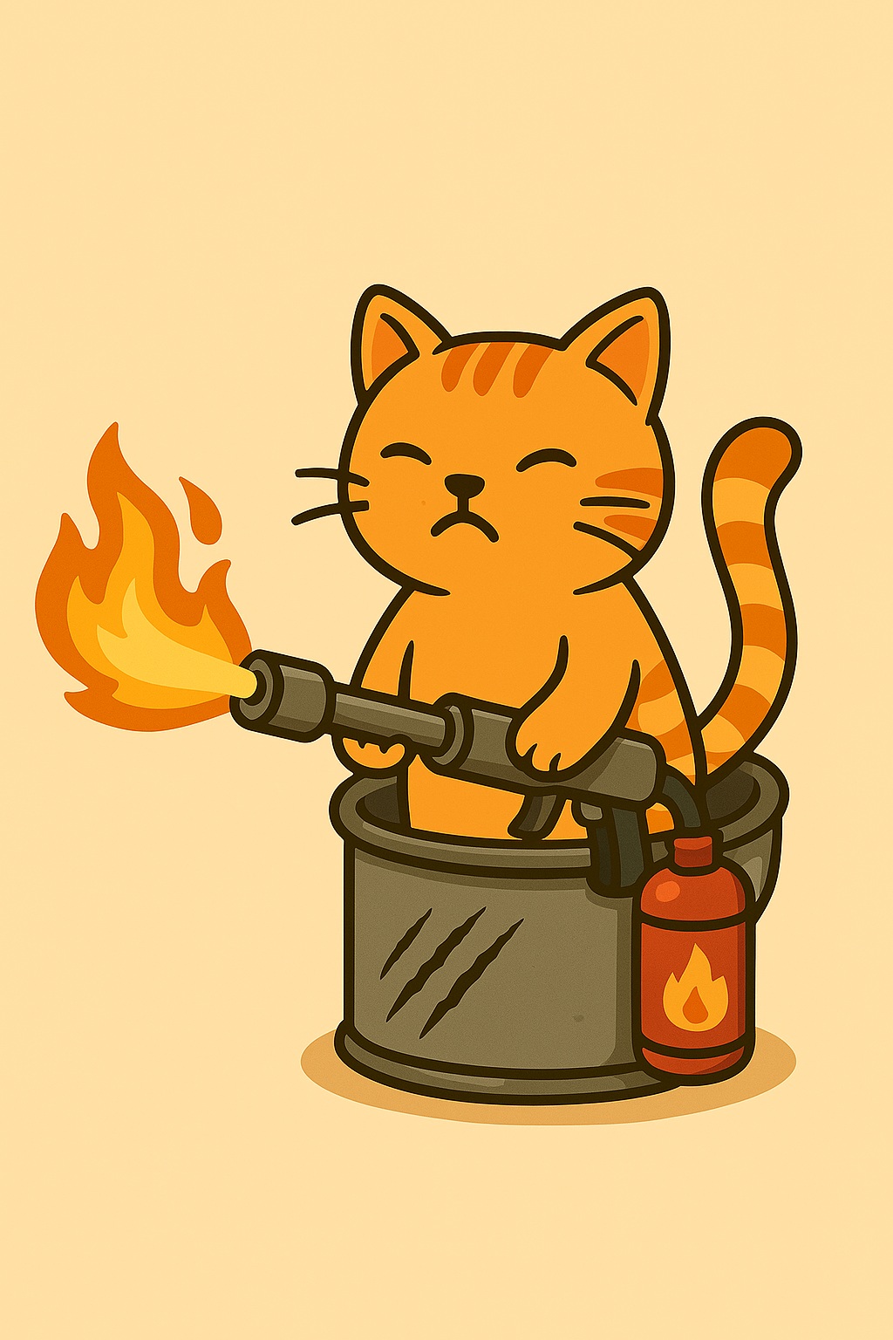

**Mechanics:**

* **Core Mechanics:** The game is a simple tower placement on a set track of enemies.
* **Progression Mechanics:** New towers are purchased with coins. Each tower can also be upgraded by upgrading the leader of the tower type. Each level is split into 10 waves of enemies. There are a series of settings as the player progresses.
* **Resource Management:**
  + Coins:
    - Player will begin with a base number of coins to purchase their first towers.
    - Each upgrade of tower cost more that the last.
    - More coins are earned with rats being killed.
  + Cheese:
    - The magical cheese is used as the health bar.
    - At the end of the first round, a quarter of the cheese is stolen.
    - Cheese health bar can go up with purchase of upgrades.
    - Each rat that gets through the cheese health drops.
* **Enemy Behavior:** The rats move based of the towers. So, at first, they just move along the track from A to B. The towers affect their behavior.
* **Physics & Interaction:**
  + **Tower Physics & Rat Movement Dynamics**
    - **Element-Based Interactions**
      * **Drenched Paw Tower:** Water physics affect enemy movement based on weight—light rats get pushed back easily, while bio-electric ones temporarily lose their abilities due to short-circuiting.
      * **Blazing Whisker Tower:** Fire creates frantic movement patterns. Rats move erratically, occasionally running in circles or colliding with other enemies, which might delay wave progression.
    - **Impact Through Motion & Environment**
      * **Basic Claw Tower:** Quick swipes send smaller rats tumbling backward upon impact, disrupting their movement for a brief moment. Agile rats may dodge but risk losing speed.
      * **Sticky Paws Tower:** When a cat pounces, the sticky grip forces rats to struggle against an unseen force, reducing their momentum. Some rats might shake free faster, while weaker ones remain stuck longer.
      * **Cat Nap Tower:** The calming aura creates a mild field effect, where rats voluntarily stop. Larger rats may resist but are sluggish near the tower, as if weighed down by invisible exhaustion.
      * **Pied Piper Tower:** Instead of direct impact, sound waves ripple outward, pulling rats into unintended movement patterns. Rats near the edge might wobble uncertainly before fully succumbing.
      * **Yarn Ball Tower:** The rolling yarn behaves like a slow-moving hazard. When rats collide with it, they bounce off, occasionally getting caught and spun around before falling off its path.
    - **Unique Defensive Physics**
      * **Mouse Trap Tower:** Mechanical traps snap down instantly when triggered, stopping forward movement altogether. If placed in clusters, it can create a chain reaction of halted rats.
      * **Sticky Trap Tower:** The adhesive effect varies with rat size. Smaller rats get completely stuck momentarily, while larger ones struggle against the slowing force but ultimately push through.
      * **Fish Bone Tower:** Piercing projectiles create directional knockback effects; hitting a rat in the side might cause them to stagger toward an unintended direction.
      * **Tuna Storm Tower:** Exploding tuna cans cause temporary concussive blasts, sending lighter rats flying back while heavier ones simply slowdown from the impact force.

**Level Design**

**World Structure:** Wave-based tower defense with narrative integration.  
**Key Locations:**

* Sacred Holy Cheese Sanctuary
  + A repository of cheeses and barrels. Shelves line the room. At one end there’s the Holy Cheese podium.
  + 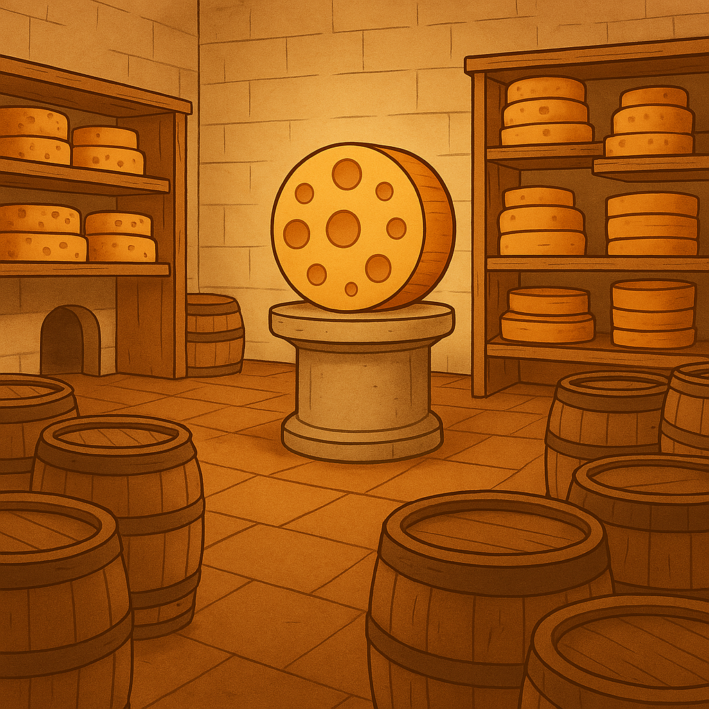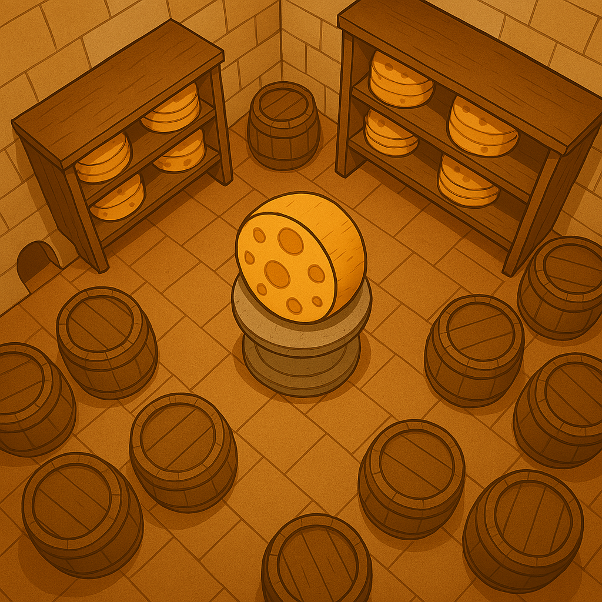
* The Gouda Grove
  + The farmers vegetable garden. Veggies line the path. The Holy cheese is on a palanquin made from egg crates.
  + 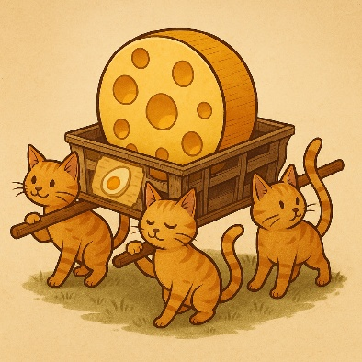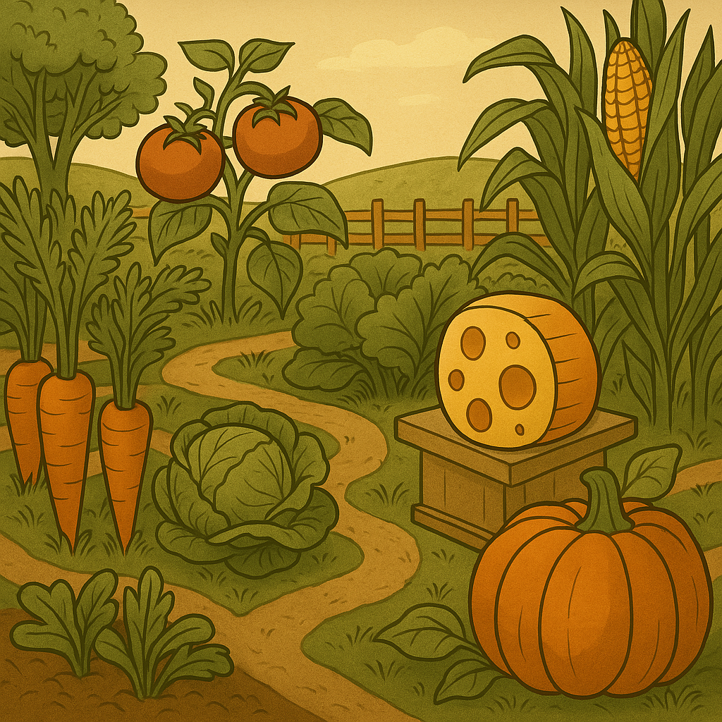
* The Fromage Forge
  + The Farmer’s Kitchen. Dangerous things like the over, knives, and heavy objects. Food on counters.
  + 

**Art & Aesthetics**

**Visual Style:** *Whimsical fantasy with rich textures.*  
**UI/UX Design:** *Easy-to-navigate menus, engaging battle indicators.*  
**Animation & Effects:** *Smooth animations, exaggerated combat.*

**Sound & Music**

**Sound Effects:**

**1. Environmental & Ambience Sounds**

* Cheese Chamber Hum – A faint, mystical resonance from the Holy Cheese.
* Scurrying Pawsteps – The eerie sound of rats darting through the shadows.
* Creaking Wooden Shelves – Adds depth to the storeroom setting.
* Faint Rodent Chatter – Rats whispering their devious plans.

**2. Combat & Attack Sounds**

* Claw Swipes – Sharp scratching when cats attack.
* Yarn Ball Rolling – A deep thud followed by a rolling effect.
* Fish Bone Whistle – High-pitched sound when sharp bones are thrown.
* Magic Cheese Explosion – A crackling burst infused with mystic energy.
* Trap Snap – Sudden mechanical crunch when a mouse trap activates.

**3. Mutant Rat Effects**

* Shriekmaw Scream – A piercing screech that stuns enemies.
* Fleabomb Swarm – A jittery buzzing sound as fleas spread over towers.
* Titantail Footsteps – Heavy thudding as massive rats stomp forward.
* Stormtail Surge – Electric crackling and energy bursts.
* Gutrotter Fumes – A sickly bubbling sound of toxic emissions.

**4. Wardens & Hero Sounds**

* Clawdius Maximus Rally Cry – A fierce battle roar.
* Whisker Mage Chant – Arcane murmurs when casting cheese magic.
* Meowdusa Stone Gaze – A deep, resonant vibration signaling petrification.
* Pied Piper Melody – A hypnotic flute tune luring rats astray.

**5. Victory & Defeat Effects**

* Cheese Sparkles – A soft, magical chime when the cheese is preserved.
* Rat Gnawing Frenzy – A chaotic chewing sound when rats overrun defenses.
* Final Boss Growl – A deep, rumbling threat from the final boss.

**Music Style:** Epic yet playful orchestral themes.

**Voice Acting:** Stylized cat and rat voices with personality.

**Technical Details**

**Game Engine:** GODOT or Unity.

**Development Tools:**

Art: IBIS paint

Sound: FX FMOD or Pixabay Sound Effects

Music: StaffPad

**Monetization & Distribution**

**Monetization Model:**

* B2P (buy to play)
* Average Market Value:
  + Steam: $4.99 to $9.99
  + Mobile: .99 to $6.99

**Marketing Strategy:**

1. **Build a Strong Brand**

* Create a **memorable logo** and consistent visual identity.
* Develop a compelling **story** around your game to connect with players.
* Ensure branding is **consistent** across social media, websites, and app stores.

1. **Optimize for App Stores & Steam**

* Use **SEO-friendly descriptions** and **high-quality visuals** for store pages.
* Encourage **early reviews** to boost visibility.
* Offer a **free demo** to attract players.

1. **Paid & Organic Advertising**

* Run **targeted ads** on social media and gaming platforms.
* Use **banner ads** and **video trailers** to grab attention.
* Consider **collaborations** with other developers for cross-promotion.

1. **Steam Wishlist Campaign**

* Create a **Steam store page** for their game before launch, allowing players to **wishlist** it. This helps build hype, gauge interest, and improve visibility in Steam’s algorithm.

**Production Timeline & Team**

**Development Phases:**

Concept → Complete June 2

Alpha → June 3 to June 23

Beta → June 24 to July 21

Launch → August 15

**Team Roles:**

Lead Programmer/ Voice Actor: Edward Fry

Programmer/ Voice Actor: Elizabeth Fry

Art/ Music/ Voice Actor: Thomas Fry

Writer/ Sound Effects/ Marketing/ Voice Actor: Linda Fry

Testing/ Voice Actor: Anthony Fry